### **Name : Arya Manoj Madhavi**

### **CLASS : D15B**

### **Roll no : 31**

**ADVANCED DEVOPS CASE STUDY**

### **Simple Cloud-Based Application Deployment**

* **Concepts Used**: AWS Cloud9, S3, and EC2.
* **Problem Statement**: "Develop a simple HTML page using AWS Cloud9 and deploy it to an S3 bucket for static website hosting. Then, set up an EC2 instance to serve as a backup server for the website."
* **Tasks**:
  + Create a basic HTML page using AWS Cloud9.
  + Deploy the HTML page to an S3 bucket and enable static website hosting.
  + Launch an EC2 instance and configure it to serve the same HTML page as a backup.

#### **Introduction**

Cloud computing has revolutionized the way applications and websites are developed, deployed, and maintained. AWS (Amazon Web Services) provides a scalable and efficient ecosystem for application deployment. This report covers a simple cloud-based application deployment process using AWS Cloud9, S3, and EC2 to demonstrate the development and hosting of a static website with a backup server.

The goal is to:

* Develop a basic HTML page using AWS Cloud9.
* Deploy it to an S3 bucket for static website hosting.
* Set up an EC2 instance to serve as a backup in case the S3-hosted website goes down.

#### **Concepts Used**

* **AWS Cloud9**: A cloud-based integrated development environment (IDE) that allows users to write, run, and debug code directly in a web browser. Cloud9 provides all the necessary tools for cloud-based development and deployment, including file editing, terminal access, and Git integration.
* **Amazon S3 (Simple Storage Service)**: A scalable object storage service that is frequently used for hosting static websites. S3 provides options for static website hosting, making it an excellent option for serving static HTML, CSS, and JavaScript files directly to end users.
* **Amazon EC2 (Elastic Compute Cloud)**: A virtual machine service that allows users to run applications on virtual servers. EC2 provides flexibility in launching instances with various operating systems and configurations, making it ideal for setting up backup web servers.

### **IMPLEMENTATION :**

### **Step 1: Set Up AWS Cloud9 Environment**

1. **Log into AWS Management Console**:
   * Go to the [AWS Management Console](https://aws.amazon.com/console/) and sign in with your credentials.

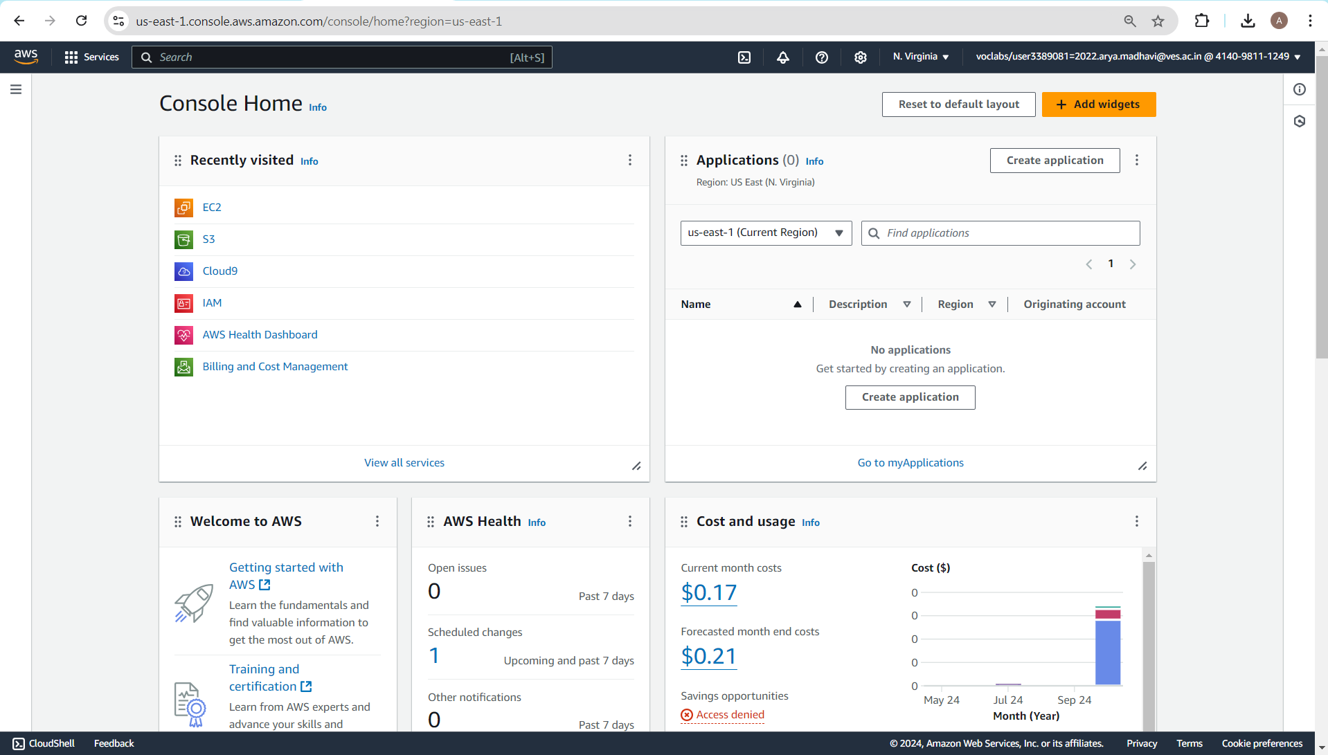

1. **Create a Cloud9 Environment**:
   * In the AWS Management Console, search for **Cloud9** and open it.

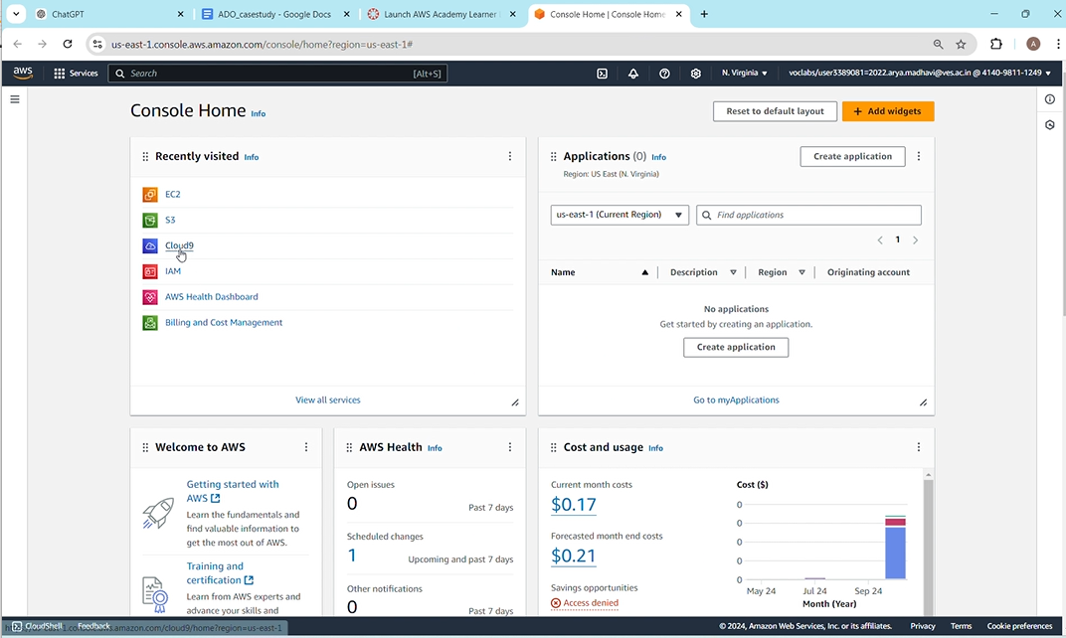

* + Click on **Create environment**.

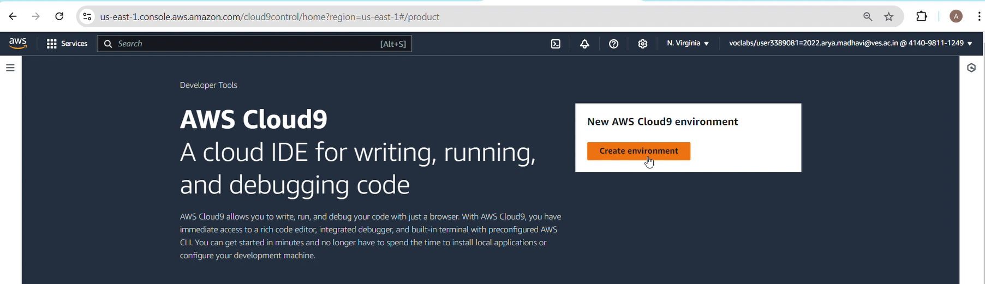

* + Give your environment a name (e.g., "SimpleWebsiteEnv") and provide a brief description if needed.
  + Choose the default EC2 instance type and other settings.
  + Click **Next step** and **Create environment**.

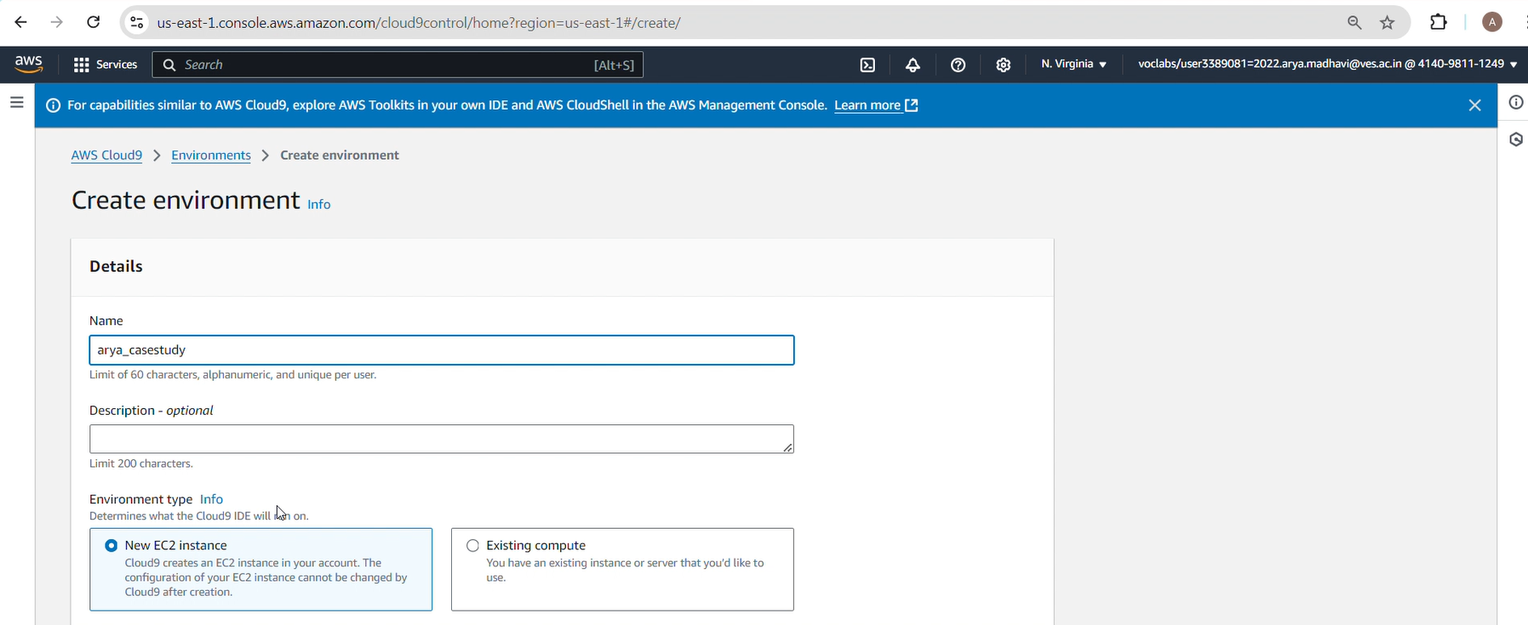

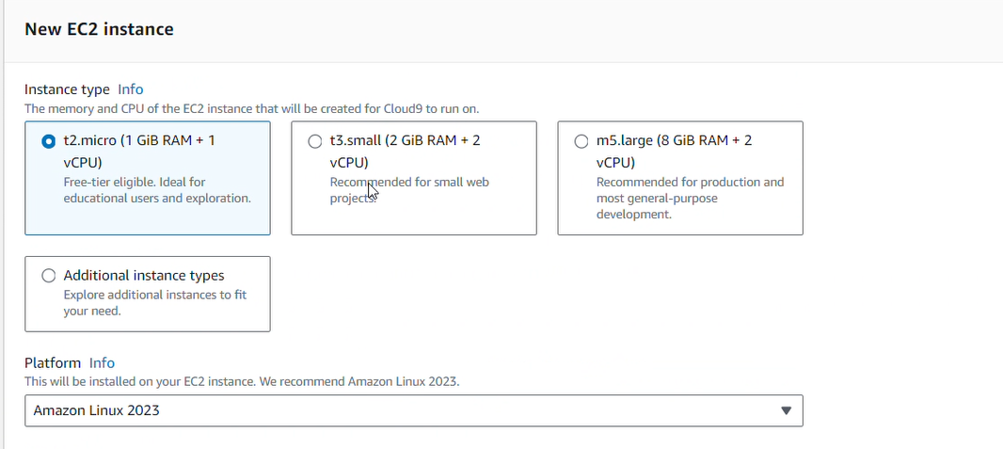

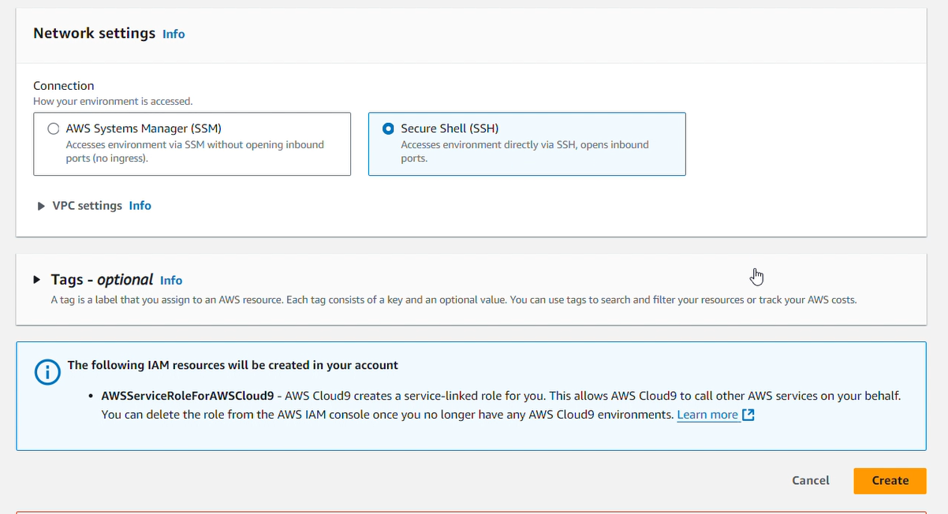

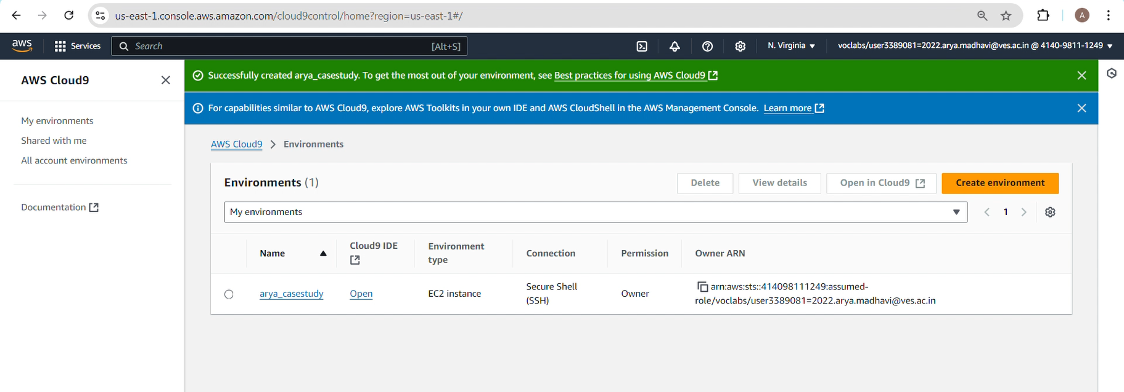

1. **Create the HTML Page**:
   * Once your Cloud9 environment is ready, create your HTML page.

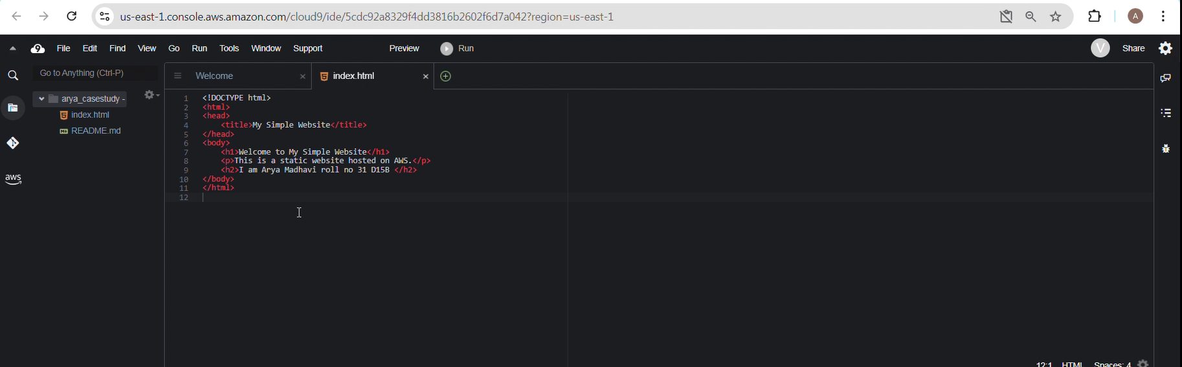

1. **Check the HTML page**:
   * You can check the contents of the index.html file in the Cloud9 IDE to ensure everything is correct.

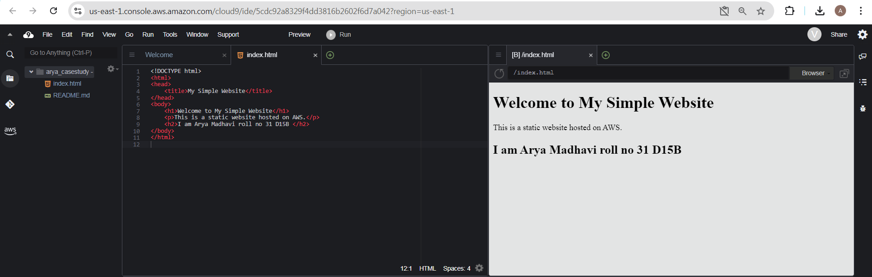

### **Step 2: Deploy HTML Page to S3**

1. **Create an S3 Bucket**:
   * Go to the AWS Management Console and search for **S3**.
   * Click on **Create bucket**.

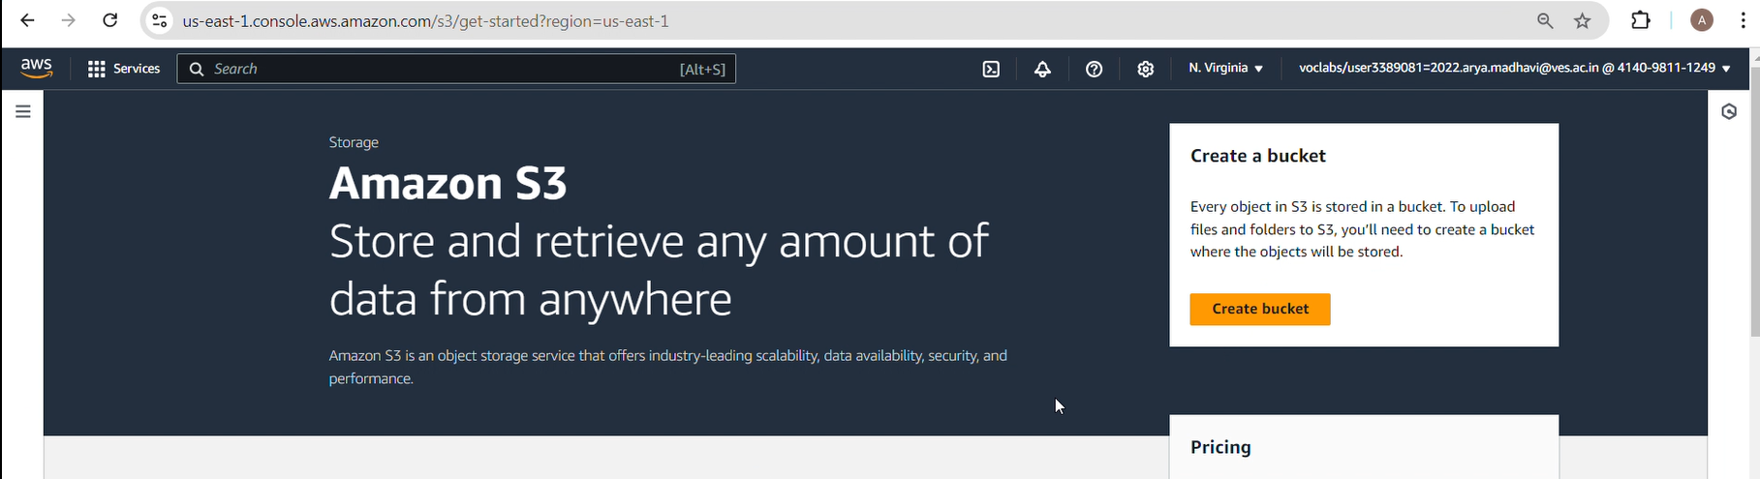

* + Give your bucket a unique name (e.g., "simple-website-bucket-123").
  + Choose the region that is closest to you.

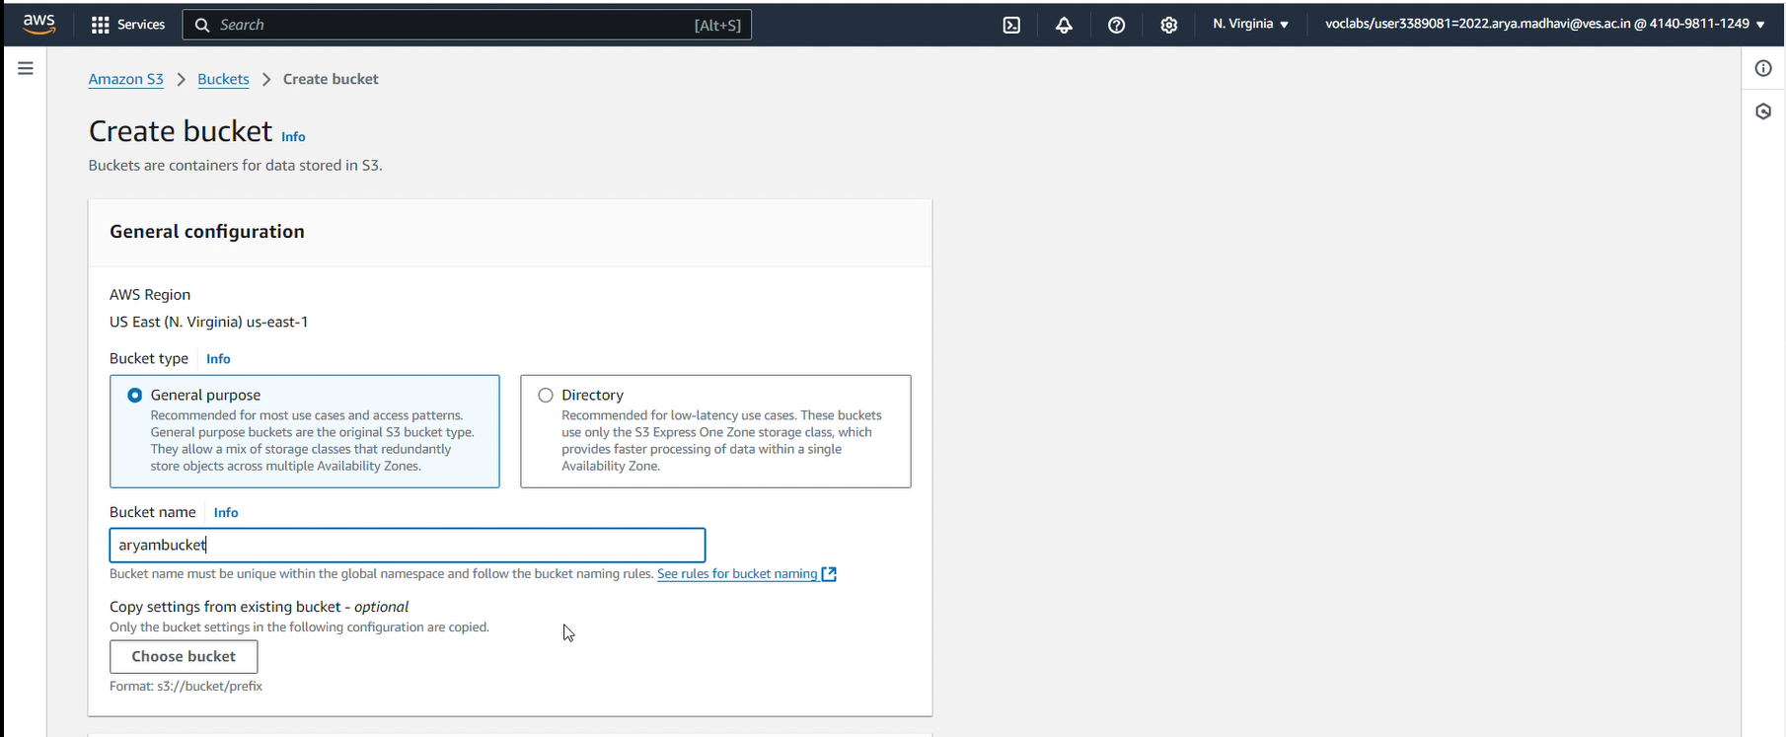

* + Uncheck the **Block all public access** option to allow public access to your website (this step is important for static website hosting).
  + Acknowledge the warning about public access, then click **Create bucket**.

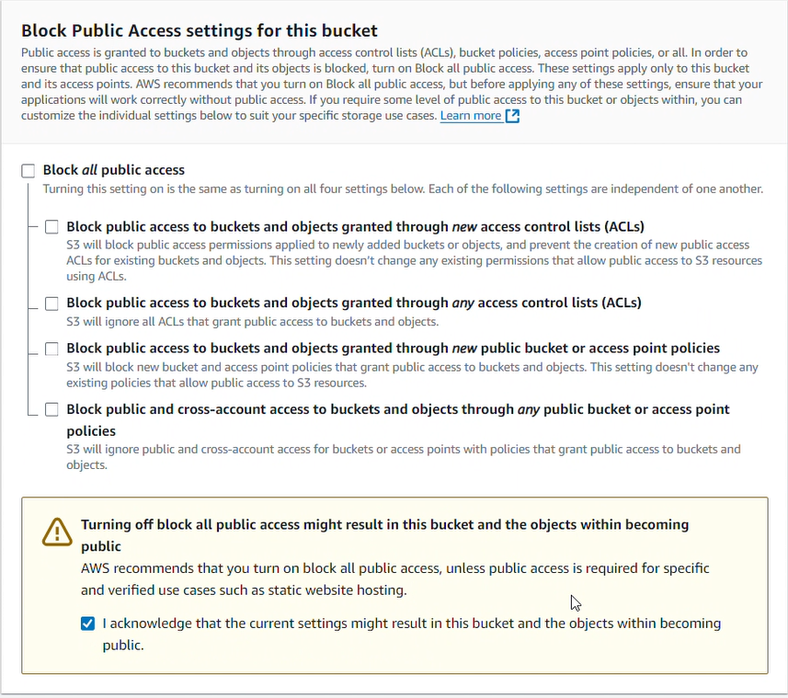

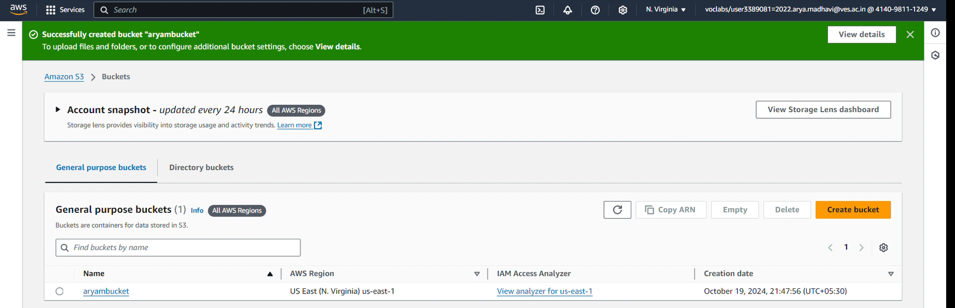

1. **Upload the HTML Page to the S3 Bucket**:
   * Open your S3 bucket and click **Upload**.

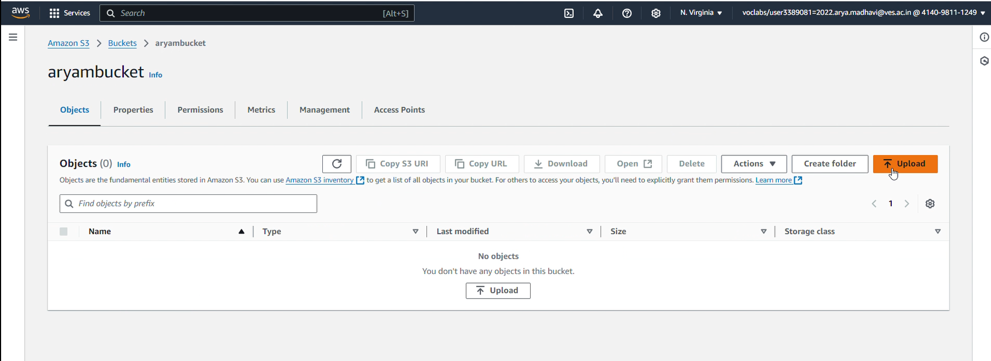

* + Click **Add files** and choose the index.html file from your Cloud9 environment (you can download it to your local machine first if necessary).

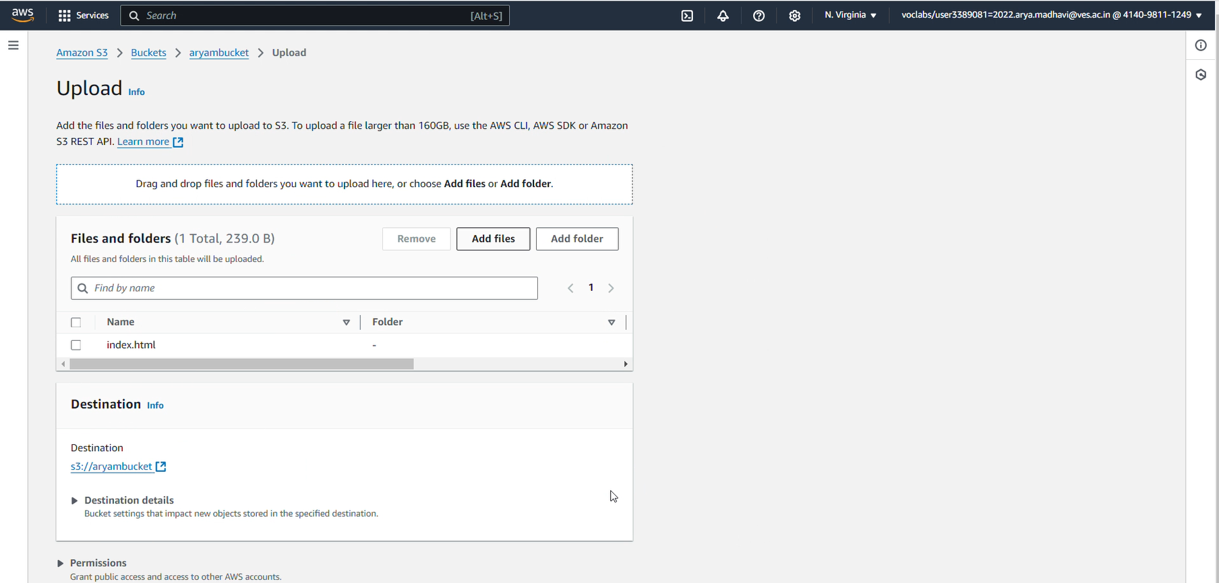

* + Click **Upload** to upload the HTML file.

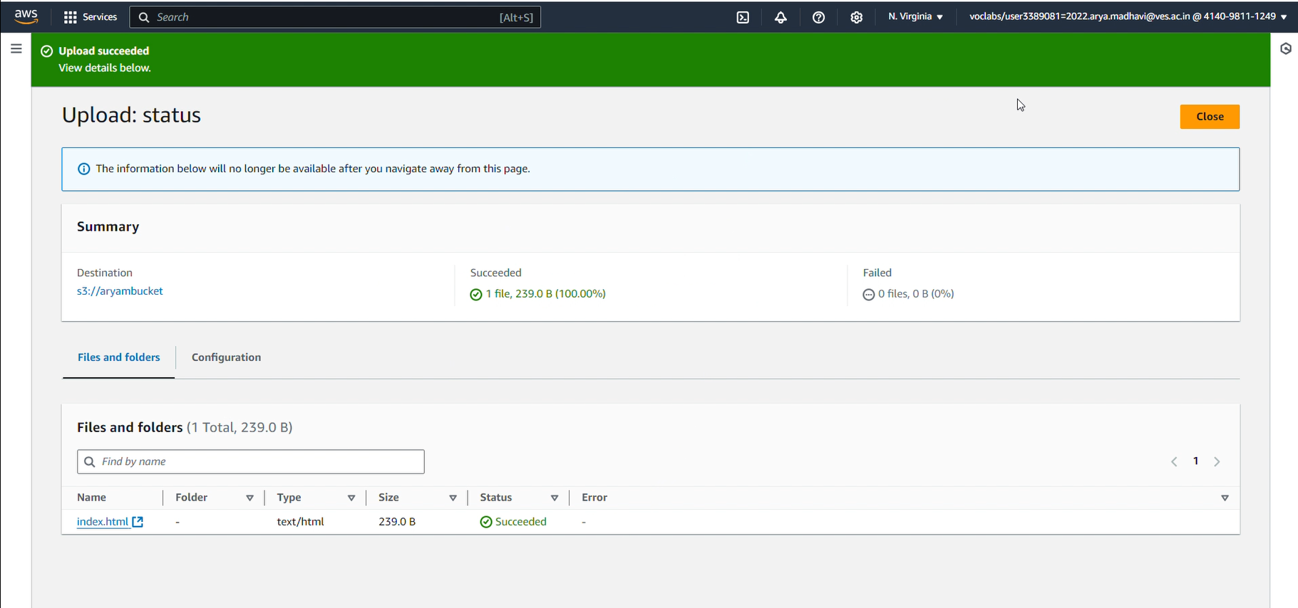

1. **Enable Static Website Hosting**:
   * Go to the **Properties** tab of your S3 bucket.
   * Scroll down to **Static website hosting** and click **Edit**.
   * Select **Enable**.
   * For the **Index document**, enter index.html.
   * Click **Save changes**.

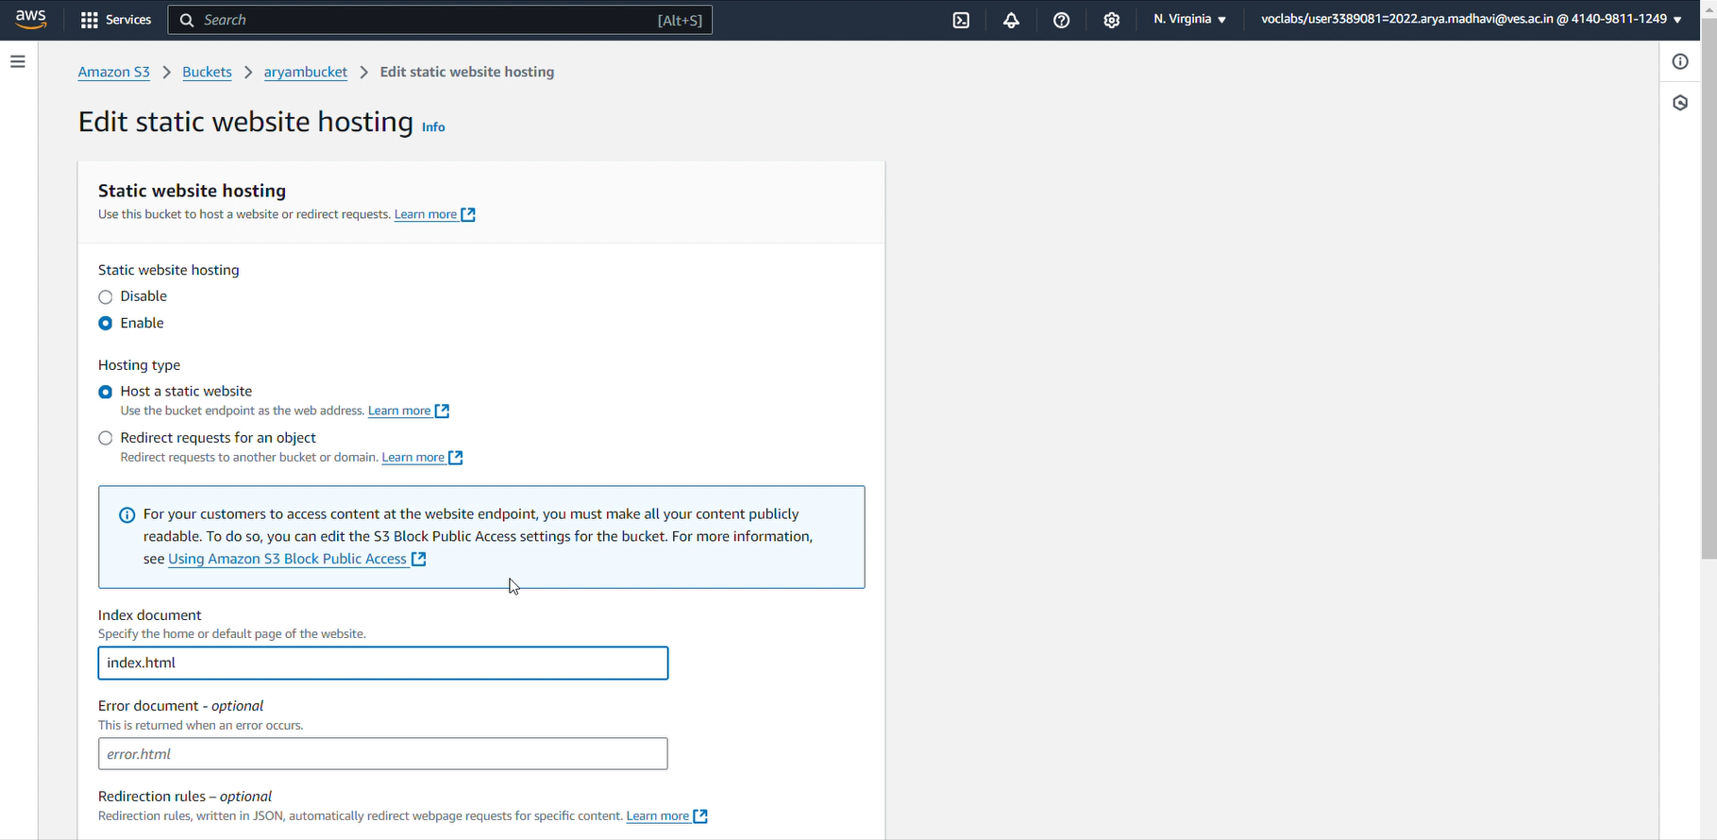

1. **Make the HTML Page Public**:

* **Open Your S3 Bucket**:
  + Go to the AWS Management Console and navigate to **S3**.
  + Click on the bucket that you created for hosting your website.
* **Set the Bucket Policy**:
  + Click on the **Permissions** tab.
  + Scroll down to the **Bucket Policy** section and click **Edit**.
  + Add the following bucket policy, replacing your-bucket-name with the actual name of your bucket:  
    {

"Version": "2012-10-17",

"Statement": [

{

"Effect": "Allow",

"Principal": "*",

"Action": "s3:GetObject",

"Resource": "arn:aws:s3:::your-bucket-name/*"

}

]

}

* + Click **Save changes**.

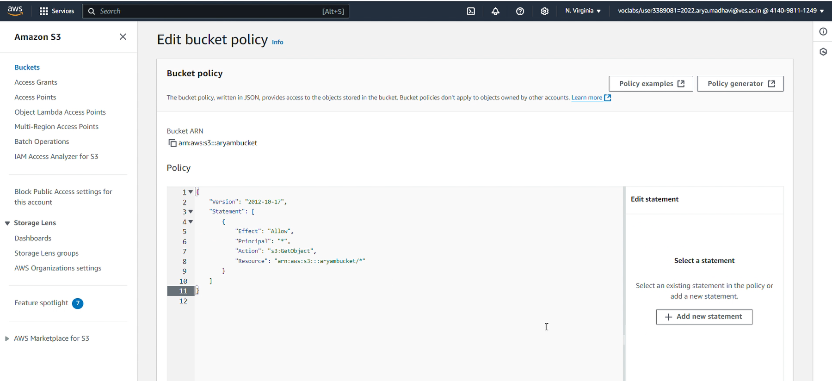

* + Now, you should be able to access your website using the S3 bucket URL provided in the Static Website Hosting settings
  + https://aryambucket.s3.amazonaws.com/index.html

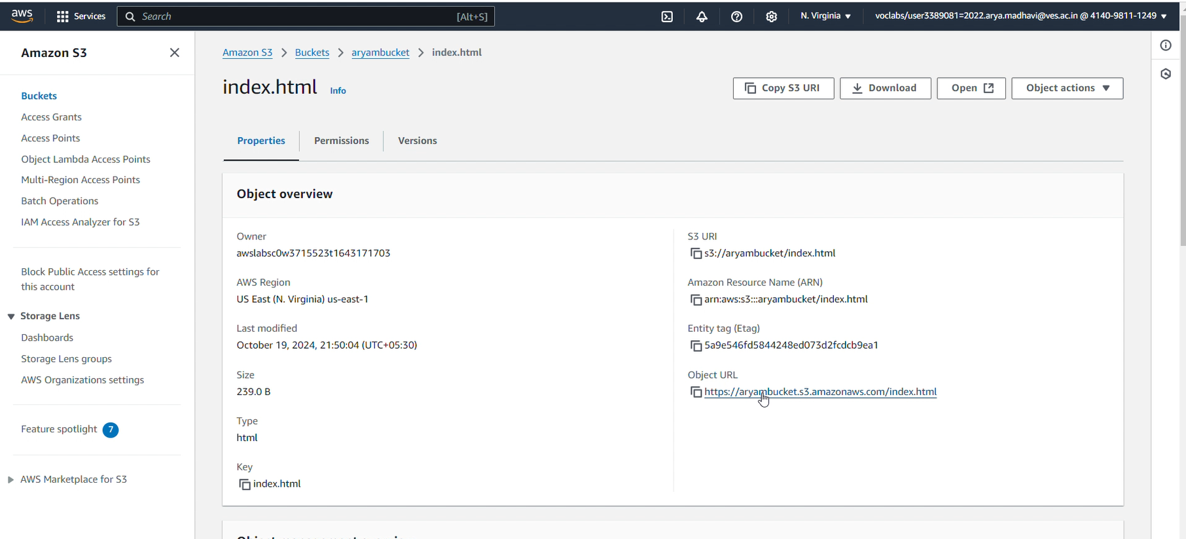

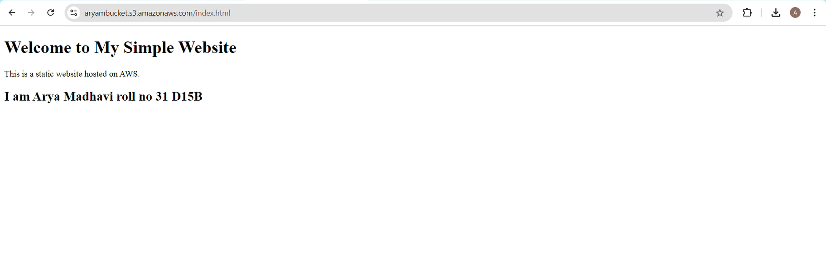

### **Step 3: Launch an EC2 Instance as a Backup Server**

1. **Launch an EC2 Instance**:
   * In the AWS Management Console, search for **EC2** and click **Launch instance**.

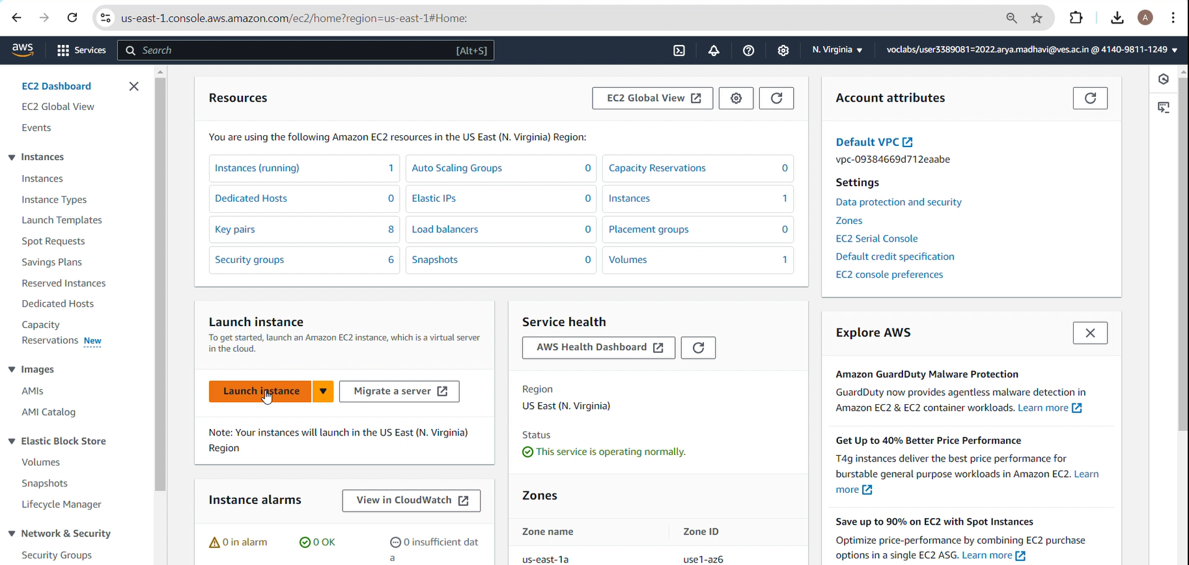

* + Select the **Amazon Linux 2 AMI** or a similar Linux-based AMI.

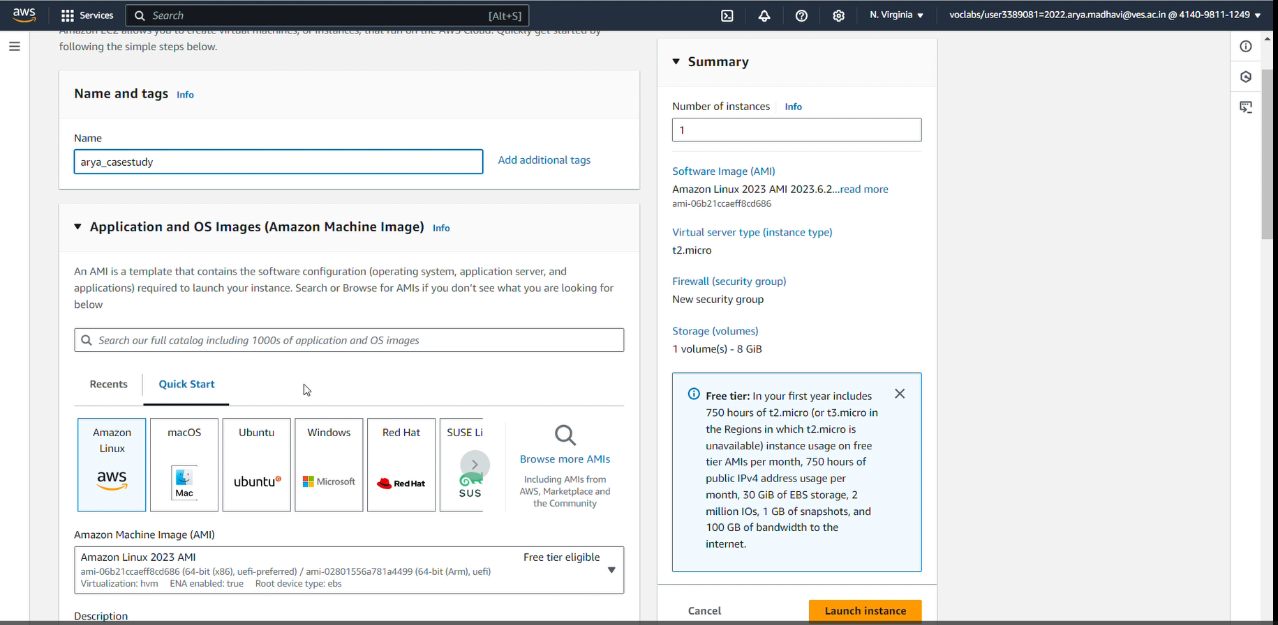

* + Choose the **t2.micro** instance type (free-tier eligible).

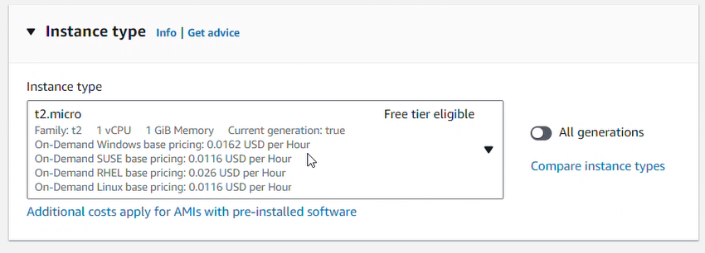

* + Configure the instance, then click **Next** until you reach the **Security Group** section.

1. **Configure the Security Group**:
   * Create a new security group or use an existing one.
   * Allow **HTTP** (port 80) access from anywhere to serve the web page.
   * Also, make sure **SSH** (port 22) access is allowed from your IP address to connect to the instance.

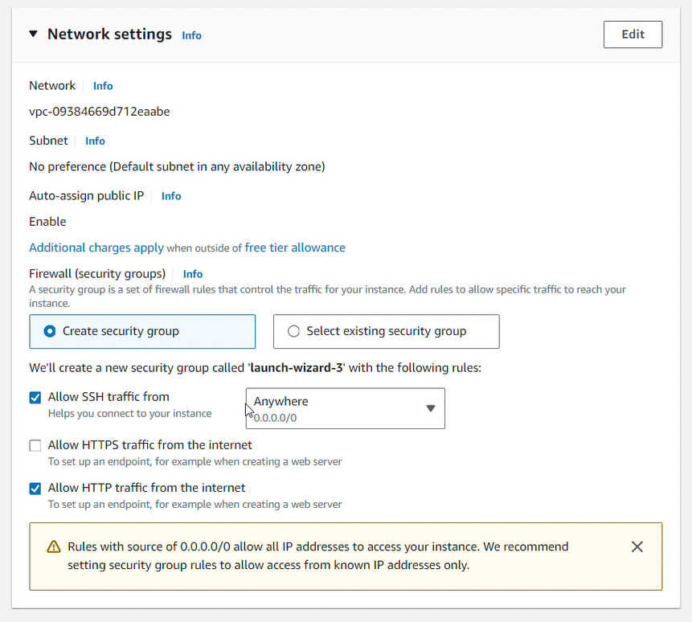

1. **Launch the Instance**:
   * Review your settings, then click **Launch**.
   * Select or create a new key pair, and save the .pem file if you create a new one.
   * Click **Launch instance**.

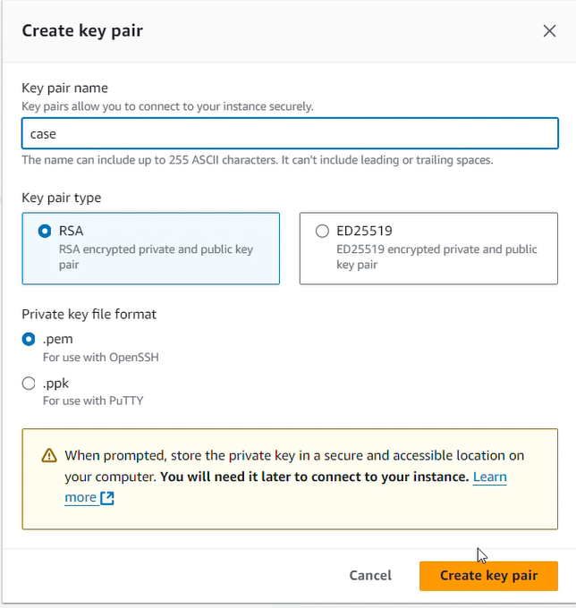

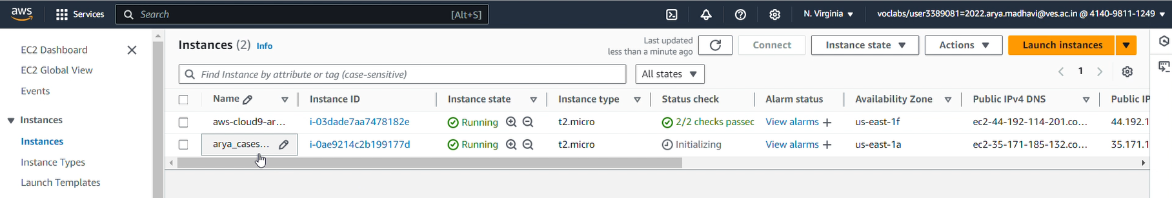

1. **Connect to the EC2 Instance**:
   * Once the instance is running, select the instance, click **Connect**, and use the SSH command provided in the console to connect to your instance.

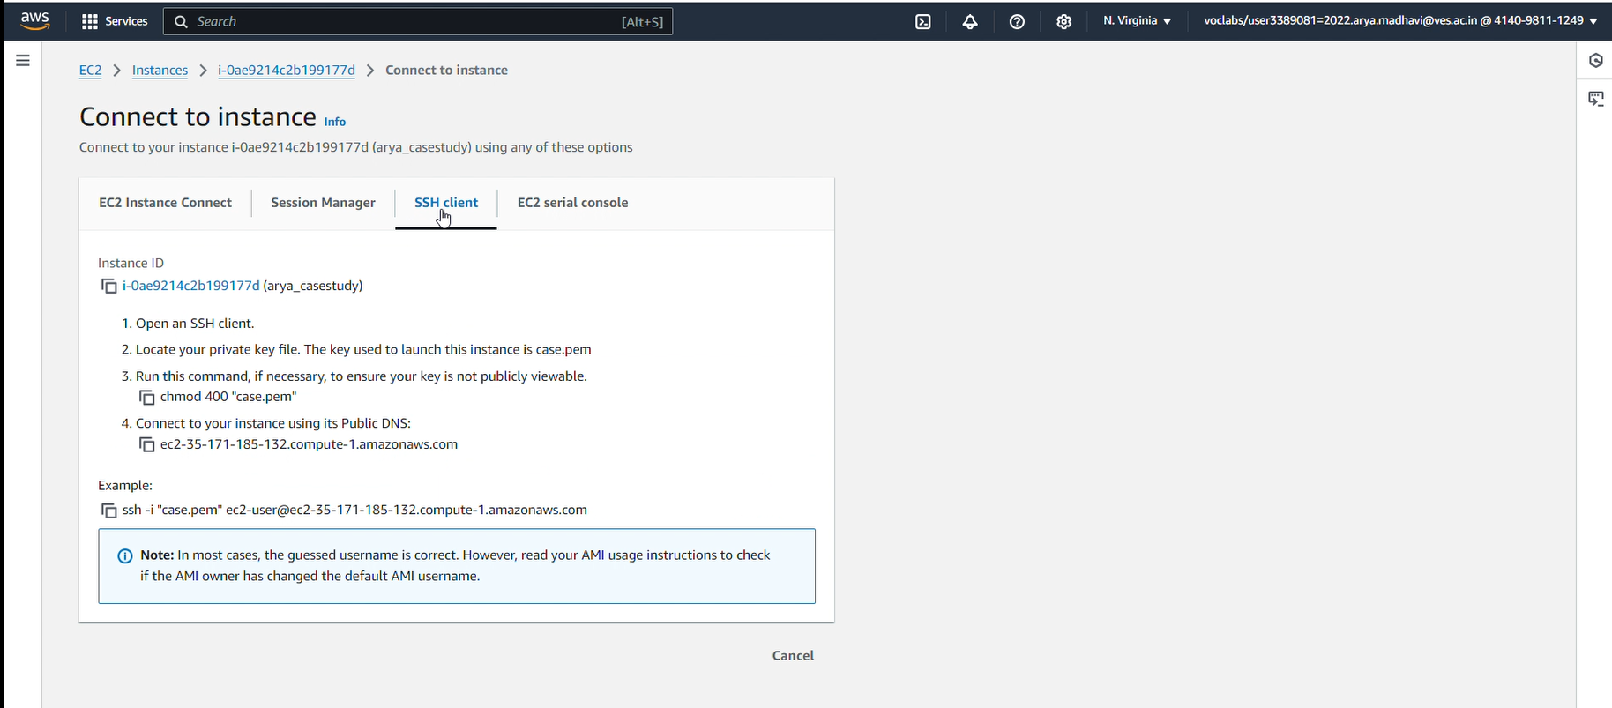

* + Use the terminal in Cloud9 or your local terminal to connect via SSH:  
    ssh -i "your-key.pem" ec2-user@your-ec2-public-ip

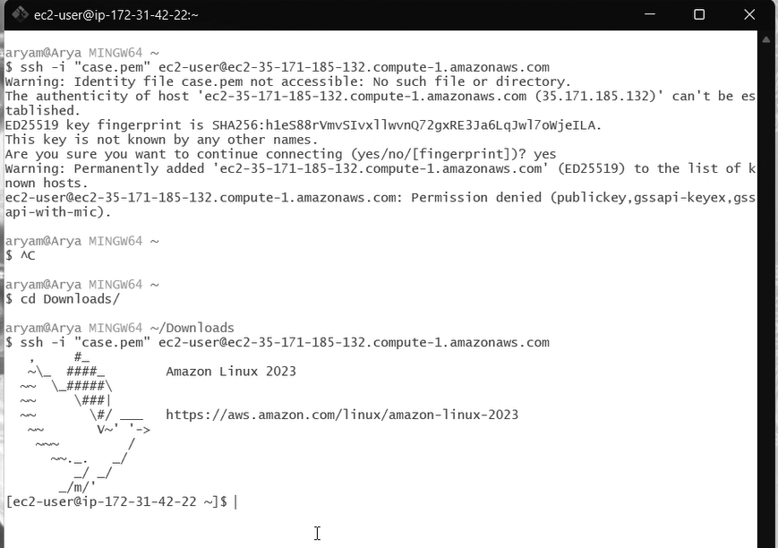

1. **Install a Web Server on EC2**:
   * After logging in to your EC2 instance, install Apache HTTP Server:  
     sudo yum update -y

sudo yum install httpd -y

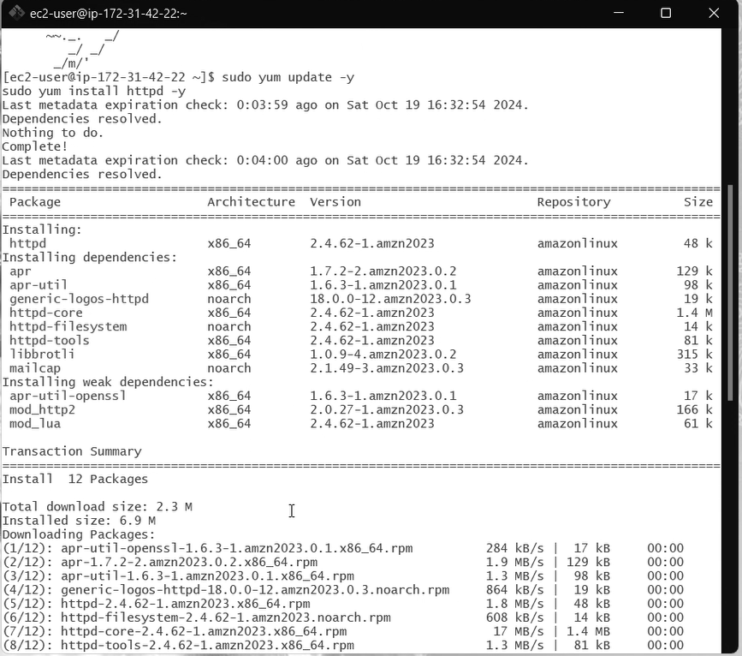

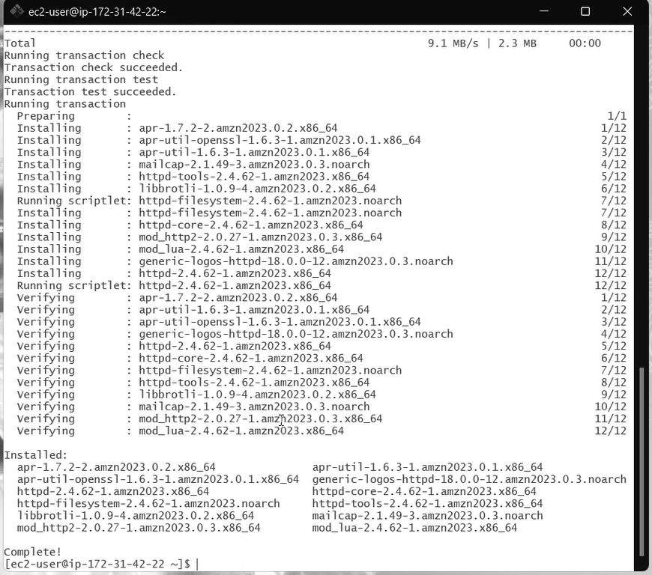

1. **Copy the HTML Page to EC2**:

* **Open a Text Editor**:

Once connected to the instance, you can use a text editor like nano to create your HTML file. Run the following command:

sudo nano /var/www/html/index.html

If the directory doesn’t exist, you can create it with sudo mkdir -p /var/www/html first.



* **Enter the HTML Content**:

The nano editor will open. You can then enter the following HTML code directly into the editor:

<!DOCTYPE html>

<html>

<head>

<title>Backup Server</title>

</head>

<body>

<h1>This is the backup server for the website.</h1>

<p>The main website is hosted on S3.</p>

</body>

</html>

* **Save the File**:

After entering the HTML code, press Ctrl + O (the letter O, not zero) to save the file. Then press Enter to confirm the file name.

Next, exit the editor by pressing Ctrl + X.

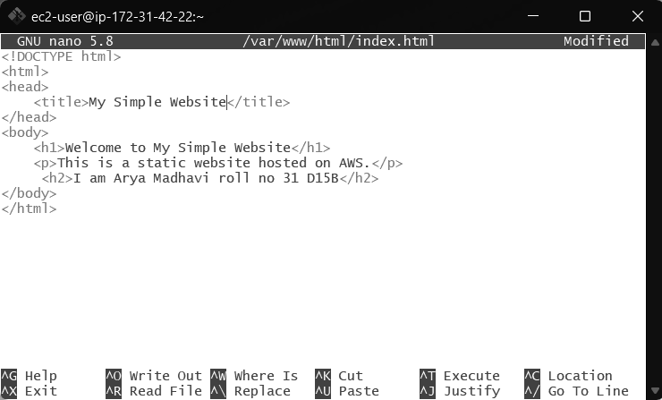

* **Check the Document Root**:

You can verify that your HTML file is created by listing the contents of the

ls /var/www/html directory:

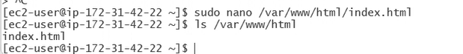

1. **Start the Web Server**:
   * Start Apache and ensure it runs at startup:  
     sudo service httpd start

sudo chkconfig httpd on

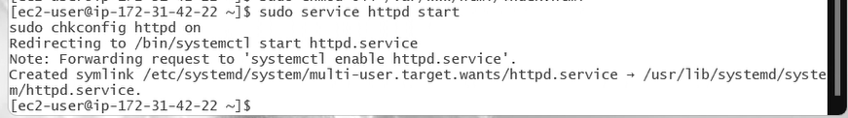

1. **Test the EC2 Website**:
   * Open your browser and navigate to the public IP address of your EC2 instance. You should see the HTML page served from the backup server.
   * 3.84.132.159 -Public IPv4 address

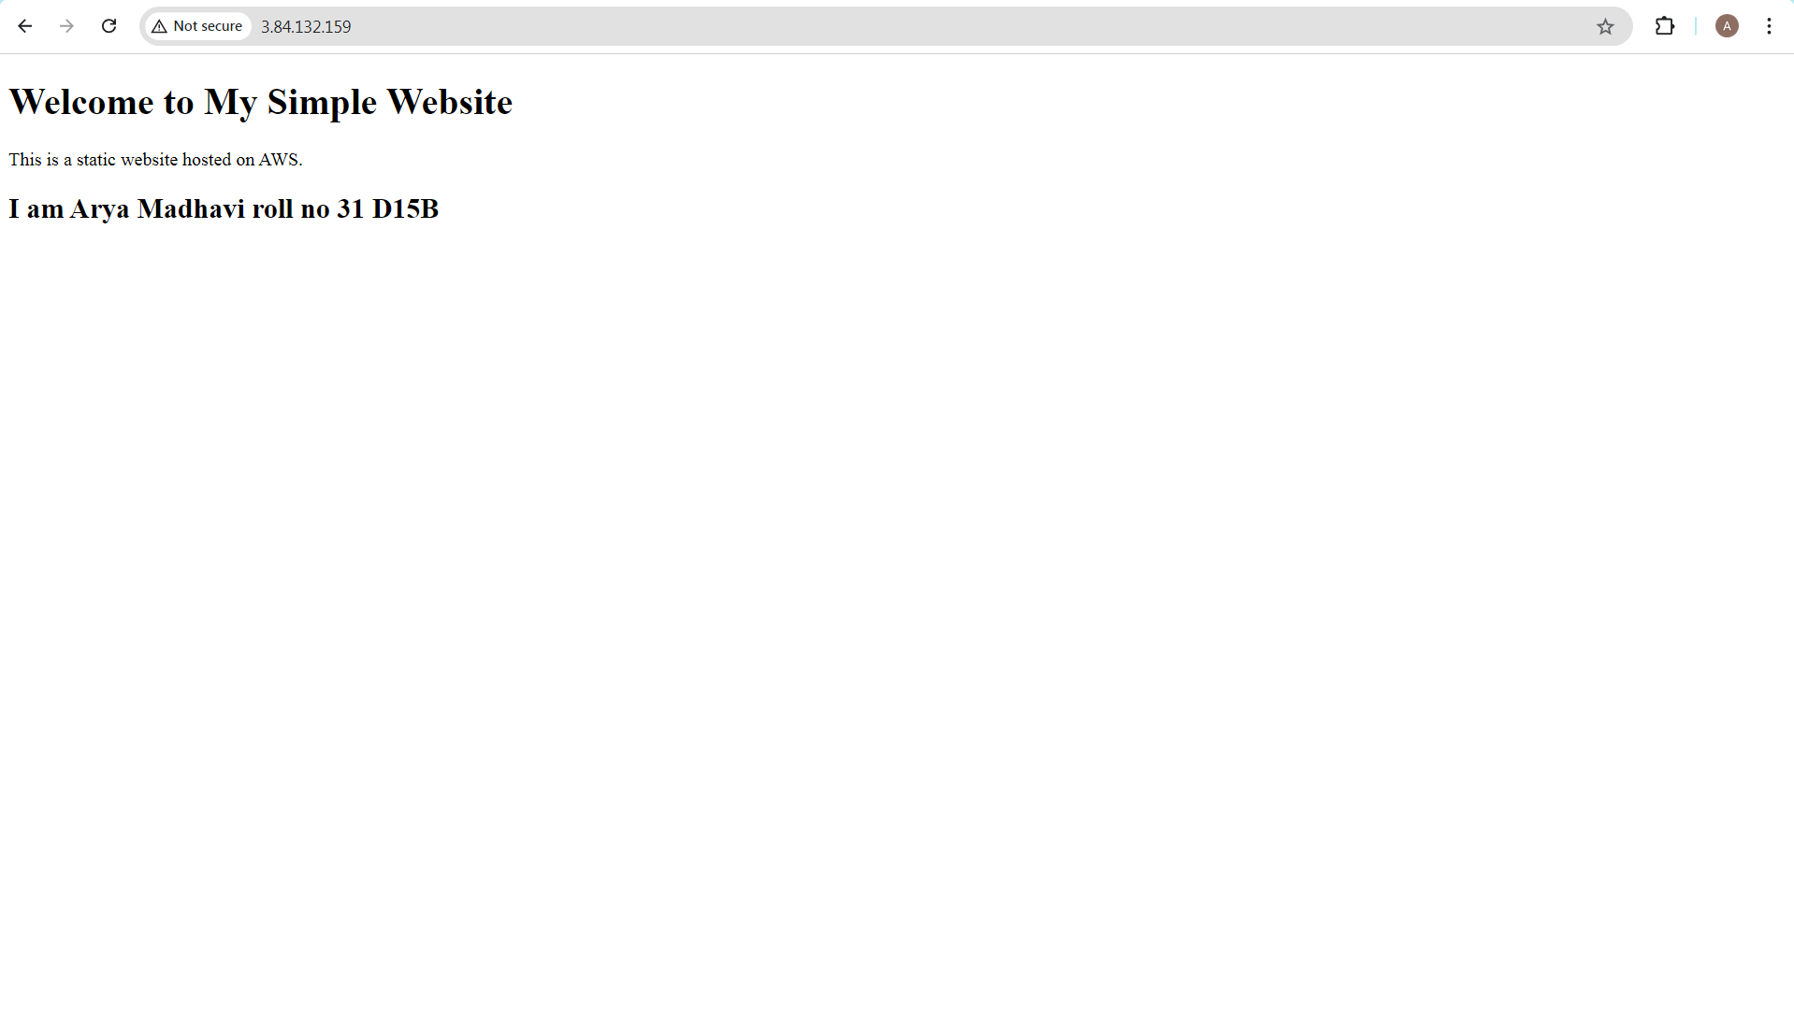

**ERROR:**

In step 2 . 4 This XML file does not appear to have any style information associated with it. The document tree is shown below.

<Error> <Code>AccessDenied</Code> <Message>Access Denied</Message> <RequestId>843TQAGXXA6Q044Z</RequestId> <HostId>hdrsGEkVFDRh40R77SBDjgdGZjpAZrKB5+5iAM2Dr24ohmNLcBVo4u9lslpislPRx0dlcg3ofjo=</HostId> </Error>

Solved by Updating the permissions of bucket policy.

**CONCLUSION :**

In this exercise, we created a simple HTML page using AWS Cloud9, deployed it to an S3 bucket for static website hosting, and set up an EC2 instance as a backup server. S3 served as the primary host for the static content, offering a scalable and cost-effective solution, while the EC2 instance, configured with Apache, provided redundancy in case of failure. This demonstrated how AWS services like Cloud9, S3, and EC2 can be integrated to build a basic, resilient web application with both static hosting and backup server capabilities.